**PROJECT PERIOD II**

***TEACHER: TÔ HOÀNG ANH***

***OUR TEAM:***

* ***NGUYỄN CÔNG HƯỞNG***
* ***NGUYỄN VĂN THI***
* ***TRỊNH VĂN VỸ***
* ***ĐỖ ĐỨC HIẾU***
* ***NGUYỄN VĂN TRÚC***

**King Snake Project**

**I.About Game:**

1. Snake and Keys: In this game, the player controls a snake character. The snake needs to eat keys scattered throughout the game area to survive and grow. As the snake consumes more keys, it scores enough to win the round.
2. Red Zone and Boss Chase: The game introduces a red zone that poses a danger to the snake. When the snake enters the red zone, a boss character is triggered and starts chasing the snake. The player must navigate the game area strategically to avoid the boss and survive.
3. Game Over: If the boss catches the snake, the game ends, and a game over screen is displayed. The player can then choose to restart or quit the game.
4. Level Up and Portal: By consuming enough keys, the snake can level up. Each level offers a more challenging gameplay experience. Once the snake reaches a certain level, a portal appears in the game area. The player needs to locate and enter the portal to move on to the next level.
5. Leaderboard: The game includes a leaderboard that tracks and displays the high scores achieved by players. This feature allows players to compare their performance with other players and strive to achieve a higher ranking.
6. Battle History: Players can view their battle history, which showcases their previous performances in the game. This feature provides a record of the player's progress and allows them to analyze their gameplay strategies.
7. Three Game Modes: The game offers three different game modes with varying difficulty levels. These modes provide options for players of different skill levels, allowing them to choose a gameplay experience that suits their preferences.
8. Personal Profile: Each player has a personal profile that displays their achievements and progress in the game. This profile may include information such as the player's level, high scores, unlocked items, and completed challenges.
9. Skins: Players can customize the appearance of their snake character using different skins. Skins are cosmetic enhancements that change the visual appearance of the snake, adding a personal touch to the gameplay experience.
10. Shop: The game features a shop where players can purchase various in-game items and upgrades. These items may include power-ups, additional skins, or other enhancements that can aid the player in their gameplay.
11. MiniGame: Upon entering the MiniGame, players are presented with a betting interface. They have to place a bet with the boss based on the rules of the rock-paper-scissors game to determine if they will win or not. This adds a gambling element to the gameplay, where players can take risks and potentially earn rewards based on their betting choices.

**II.Technical Requirements:**

* MongoDB Compass: MongoDB Compass is a graphical user interface (GUI) tool for MongoDB, a popular NoSQL database. It allows developers to visually explore and interact with their MongoDB databases, making it easier to manage and analyze data.
* JavaFX Scene Builder: JavaFX Scene Builder is a visual layout tool for designing JavaFX user interfaces. It provides a drag-and-drop interface to create and modify UI components, define their properties, and arrange them in a scene. The Scene Builder generates FXML files that can be integrated with Java code.
* IntelliJ IDEA: IntelliJ IDEA is an integrated development environment (IDE) for Java programming. It provides advanced coding assistance, debugging tools, and a wide range of features to enhance developer productivity. IntelliJ IDEA supports various frameworks and technologies, making it a popular choice among Java developers.
* Regarding the source code and file structure, here is a detailed explanation:
* Root directory: The root directory is named "huongcaoha1994/King_Snake" and is located on GitHub (github.com). It serves as the main directory for the project.
* Source code directory: The source code directory is named "IdeaProjects". It contains the actual Java source code files for the project. These files are responsible for implementing the game logic, user interface, and other functionalities.
* Documentation directory: The documentation directory is also named "IdeaProjects". It houses the documentation related to the project. This documentation may include design documents, user guides, API references, or any other relevant information for developers or users.
* Testing directory: The testing directory is named "IdeaProjects". It is dedicated to storing test files and scripts used for testing the functionality and behavior of the application. These tests help ensure the quality and reliability of the code.
* Resource directory: The resource directory is named "IdeaProjects". It contains additional resources required by the application, such as images, icons, configuration files, or other non-java files used during runtime.
* Library directory: The library directory is named "IdeaProjects". It holds external libraries or dependencies required by the project. These libraries enhance the functionality of the application and are referenced by the source code.
* Configuration files: The configuration files are located in the "IdeaProjects" directory. These files store various settings and configurations related to the project, such as build configurations, deployment settings, or environment-specific configurations.
* Executable files: The executable files are also located in the "IdeaProjects" directory. These files may include compiled binaries or executables of the application that can be run directly to launch the game.

**III.User Interface Design:**

***Scene Login***

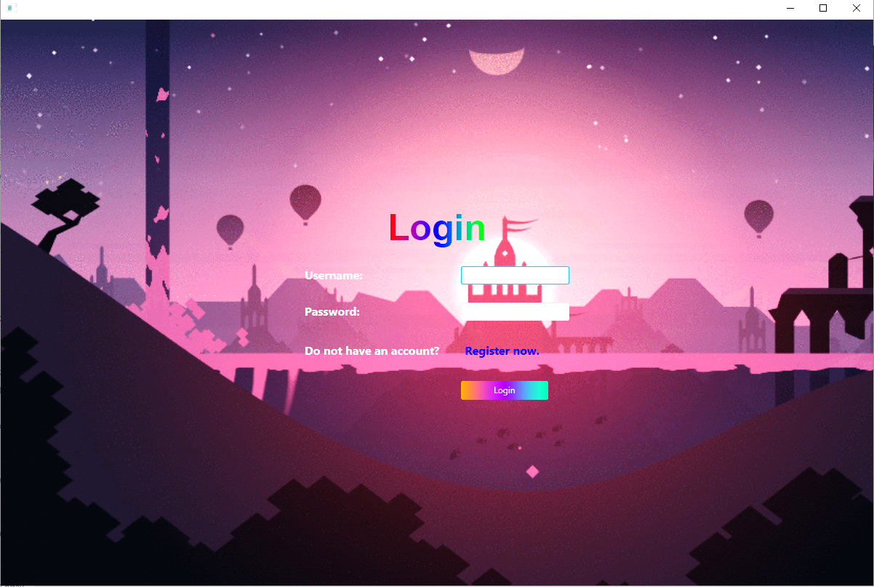

* Label: In the center of the screen, there is a label with the text "Login." This label serves as a heading or title for the login section, indicating the purpose of the screen.
* Username and Password Text Fields: Below the label, there are two text fields. The first text field is for entering the username, and the second text field is for entering the password. These text fields allow the user to input their credentials for authentication.
* Login Button: At the bottom of the screen, there is a login button. This button triggers the login process when clicked. It validates the entered username and password and allows the user to access the system or application if the credentials are correct.
* The layout and design of these components may vary depending on the specific implementation and user interface framework being used. For example, the text fields may have placeholder text to guide the user on what information to enter, and the login button may have visual effects or feedback when clicked.

**Scene Register**

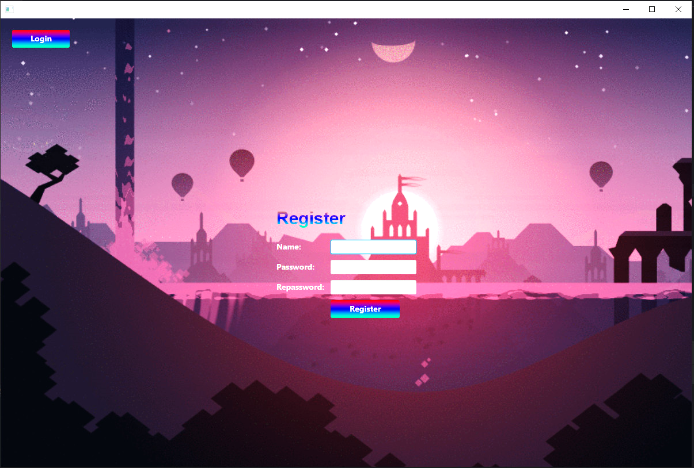

* Additionally, there might be other elements on the login screen, such as a "Register" button for users who don't have an account yet. These elements provide additional functionality and options for the user.

**Scene Main**

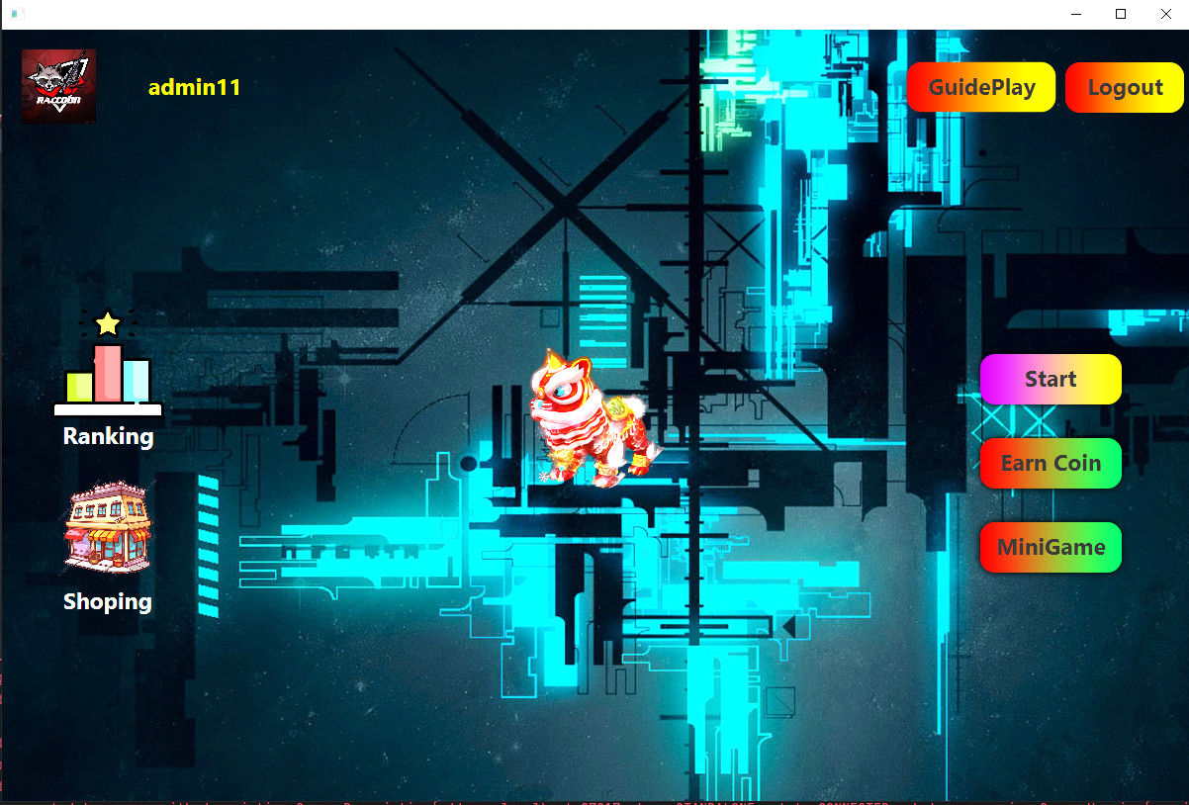

* On the main screen, the following components are present:

1. User Avatar Button: Located in the top left corner, there is a button with an inserted image representing the user's avatar. This button may display an icon or a small thumbnail image that represents the user. Clicking on this button might open a user profile.
2. Exit Button: Positioned in the top right corner of the screen, there is an exit button. Clicking on this button typically closes the application or returns the user to the previous screen.
3. Character (Moving Snake): In the middle of the screen, there is a character representing a moving snake. This character could be animated and responsive to user input. It serves as the main visual element or game object in the application.
4. Ranking Button: On the left side of the screen, there is a button labeled "Ranking." Clicking on this button triggers an action that displays a leaderboard. The leaderboard might show high scores, rankings, or achievements of players in the game.
5. Shop Button: Positioned below the ranking button on the left side of the screen, there is a button labeled "Shop." Clicking on this button opens a shop interface or menu where the user can browse and purchase in-game items, upgrades, or customizations using in-game currency or real-world currency.

* The layout and design of these components may vary depending on the specific application or game. The main screen provides a central focus on the character (snake) and offers additional functionality through the user avatar button, exit button, ranking button, and shop button. These elements enhance the user experience by providing options for customization, social interaction (through the leaderboard), and progression (through the shop).

**Scene Shop**

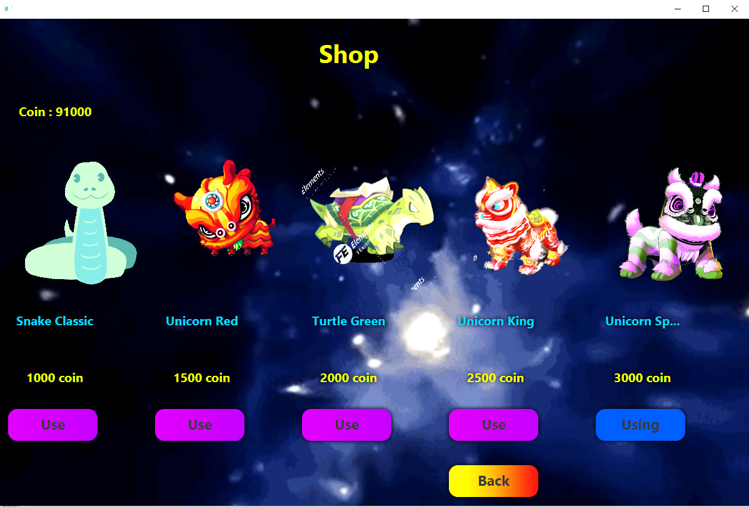

* When the "Shop" button is clicked, it opens the costume interface for the character. The costume interface consists of the following components:
* Gold Display: In the top left corner of the interface, there is a text display that shows the amount of gold the player currently possesses. This is the in-game currency that can be used to purchase costumes.
* Costumes: Below the gold display, there are multiple costume options available for the character. Each costume is displayed with its own unique design or style.
* Price and Buy Button: For each costume, there is a corresponding price displayed below it. The price represents the amount of gold required to purchase that particular costume. Additionally, there is a "Buy" button associated with each costume. Clicking on the "Buy" button allows the player to purchase the costume if they have enough gold.
* Back Button: Positioned at the bottom of the interface, there is a "Back" button. Clicking on this button returns the player to the main interface, allowing them to continue playing the game or accessing other features.
* The layout and design of the costume interface may vary based on the specific game or application. The interface provides a clear overview of available costumes, their prices, and the player's gold balance. It allows players to customize their character's appearance, promotes in-game progression by earning and spending gold, and offers a convenient way to navigate between the costume interface and the main interface.

**Scene Choose Level**

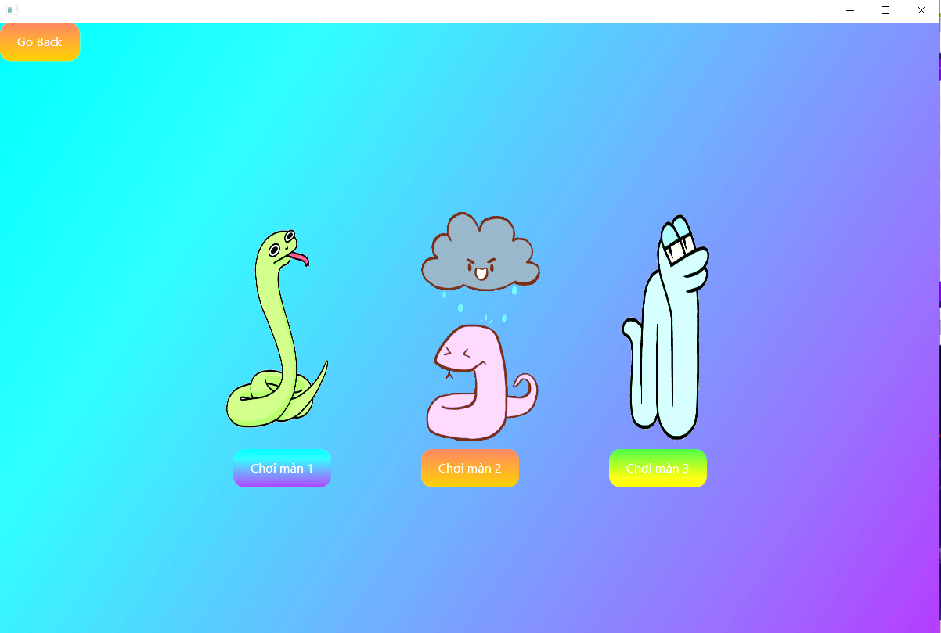

6. In the right corner of the main interface, there is a play button. When this button is clicked, it opens a menu that displays three game levels, each represented by an animated snake image indicating the difficulty level. The menu consists of the following components:

* Animated Snake Images: Below the play button, there are three animated snake images. Each image represents a different game level and visually indicates the difficulty level of that particular level. The images may vary in size, color, or animation to visually differentiate the levels from each other.
* Level Buttons: Below each animated snake image, there is a button labeled with the corresponding level name. These buttons allow the player to select and play a specific level. For example, if there are three levels named "Easy," "Medium," and "Hard," there will be three buttons labeled accordingly. Clicking on a level button starts the game at the selected difficulty level.
* The layout and design of the menu may vary depending on the specific game or application. The play button in the right corner provides easy access to the game levels. The animated snake images give players a visual representation of the difficulty level, and the level buttons allow them to choose their desired level to play. This menu design enhances the user experience by providing a clear and intuitive way to select the game difficulty and start playing the game.

**Scene Level 1**

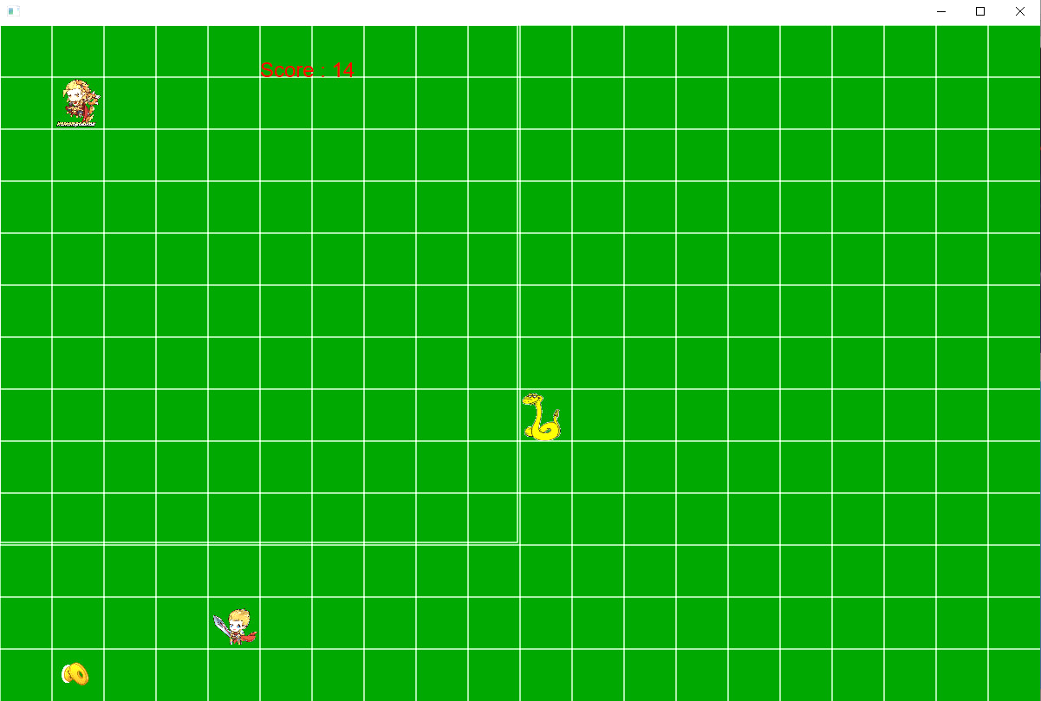

* In each game level interface, there are several components and interactions involving your character, two boss characters, and keys. The interface for each level includes the following:
* Your Character (Snake): Your character is represented as a snake on the screen. You control the snake's movement using the arrow keys on the keyboard. The objective is to navigate the snake and eat the keys while avoiding the boss characters.
* Two Boss Characters: There are two boss characters in each level. One boss is located in a dangerous zone, indicating that it poses a threat to your character. The other boss actively chases your character around the screen. The boss characters may have distinct appearances or behaviors to make them visually and behaviorally different from each other.
* Dangerous Zone: The dangerous zone is an area on the screen where one of the boss characters is located. If your character enters this zone, it becomes vulnerable to the boss's attacks or dangers. It adds an element of challenge and strategy to the gameplay.
* keys: keys items are randomly placed on the screen. These keys items serve as targets for your character to eat. When your character reaches a key item, it gains points or progresses in the game.
* Boss Reaction to keys: When your character enters the dangerous zone and consumes the randomly placed keys, both boss characters will start chasing after your character. This adds additional difficulty and urgency to the gameplay as you must avoid both bosses while maneuvering to eat the keys.
* The arrow keys on the keyboard allow you to control the movement of your character (snake) in the game level. By using these keys, you can navigate the snake to eat the keys, avoid the boss characters, and maneuver strategically to progress through the level.
* The specific design, layout, and behavior of the boss characters, dangerous zone, keys, and gameplay mechanics may vary depending on the particular game implementation. However, the overall concept involves controlling your character, avoiding dangers, and collecting key items to progress in the game.

**Scene Level 2**

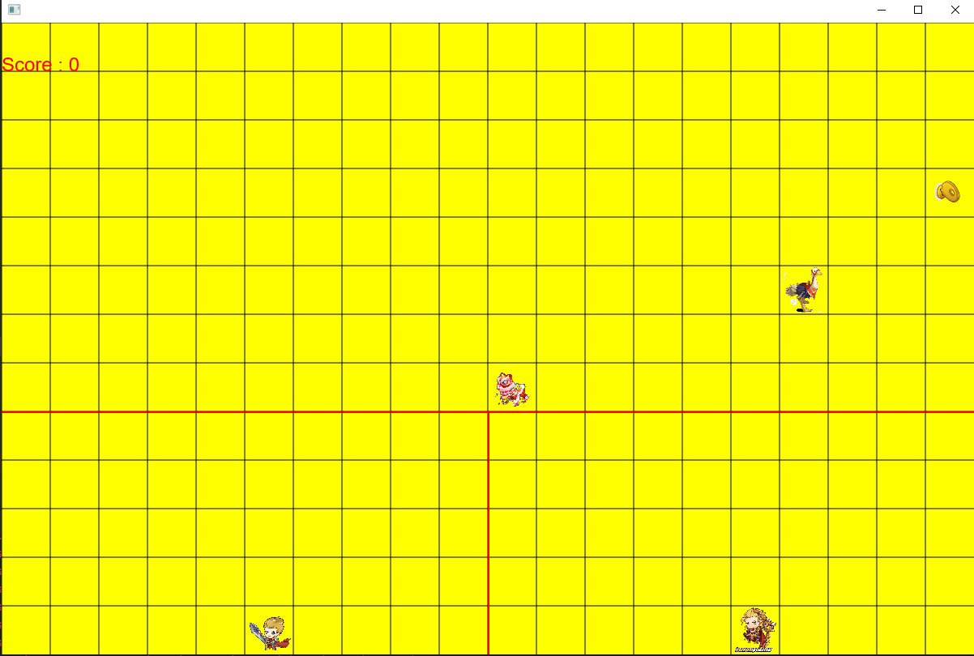

* In the second level of the game, the movement speed of the boss character will be higher compared to the first level. This means that the boss will move faster, making it more challenging for you to avoid being touched by it. You will need to react quickly and make swift movements to evade the boss and stay safe.

**Scene level 3**

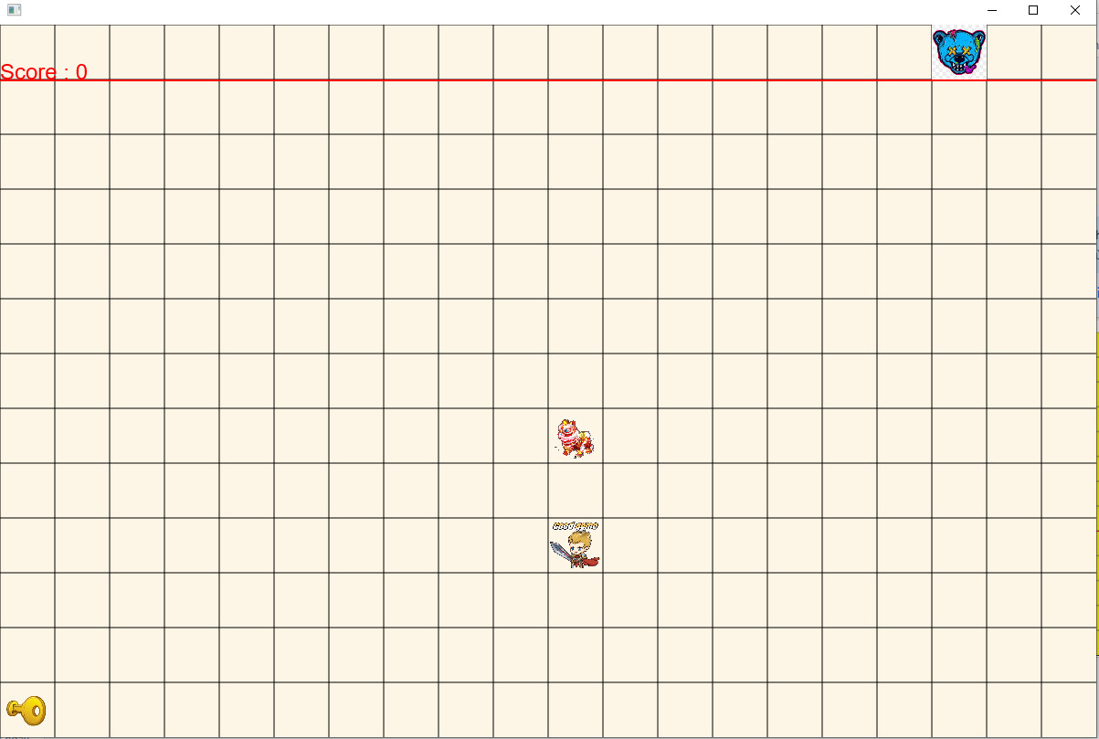

* In the third level, the boss's movement speed will further increase, making it even more difficult for you to avoid contact. The faster movement speed adds an additional layer of difficulty and tests your reflexes and agility.
* As you play through the levels and progress, there will be a certain score threshold that you need to reach. When you achieve this score, a portal will appear on the screen. The portal acts as a transition point that transports you from the current level to the next level. Passing through the portal signifies your completion of the current level and readiness to move forward.
* Upon successfully passing through the portal and transitioning to the next level, a congratulations screen will appear. This screen serves as a visual acknowledgement of your accomplishment in completing the previous level and prepares you for the challenges and excitement of the upcoming level.

**Scene Win**



* The design and layout of the congratulations screen may vary, but it typically includes celebratory visuals, a message of achievement, and perhaps some additional information or hints about the next level. It provides a brief pause in the gameplay to recognize your progress before diving into the next level's gameplay experience.
* After the congratulations screen, two buttons will be displayed:
* Back to Main Screen: This button allows you to return to the main screen of the game. Clicking on this button takes you back to the initial interface where you can access other features, such as the avatar button, ranking button, or shop button.
* Play Next Level: This button enables you to proceed to the next level of the game. Clicking on this button initiates the gameplay for the subsequent level, continuing the progression and challenges.

**Scene Lose**

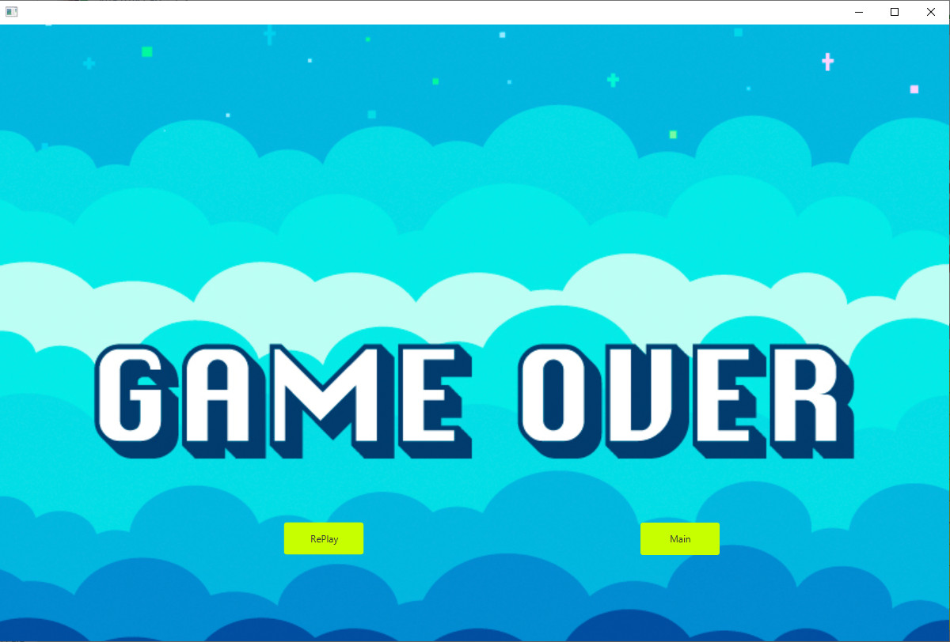

* If, during any level, your character is caught by the boss (touches or collides with it), a defeat screen will appear. The defeat screen serves as a visual indication that you were unsuccessful in completing the level and need to retry or return to a previous point in the game. It may display a message like "Game Over" or "You Lost" along with relevant visuals.
* On the defeat screen, there may be options or buttons available to you, such as:
* RePlay: This button allows you to start the current level again from the beginning, giving you an opportunity to improve your performance and successfully complete the level.
* Return to Main Screen: This button allows you to exit the current level and return to the main screen of the game, where you can choose to play a different level, access other features, or start a new game session.
* The exact design and layout of the defeat screen may vary depending on the game's aesthetics and user interface elements. It is meant to provide feedback and options to the player after an unsuccessful attempt, allowing them to choose their next course of action.

**Scene Rank**

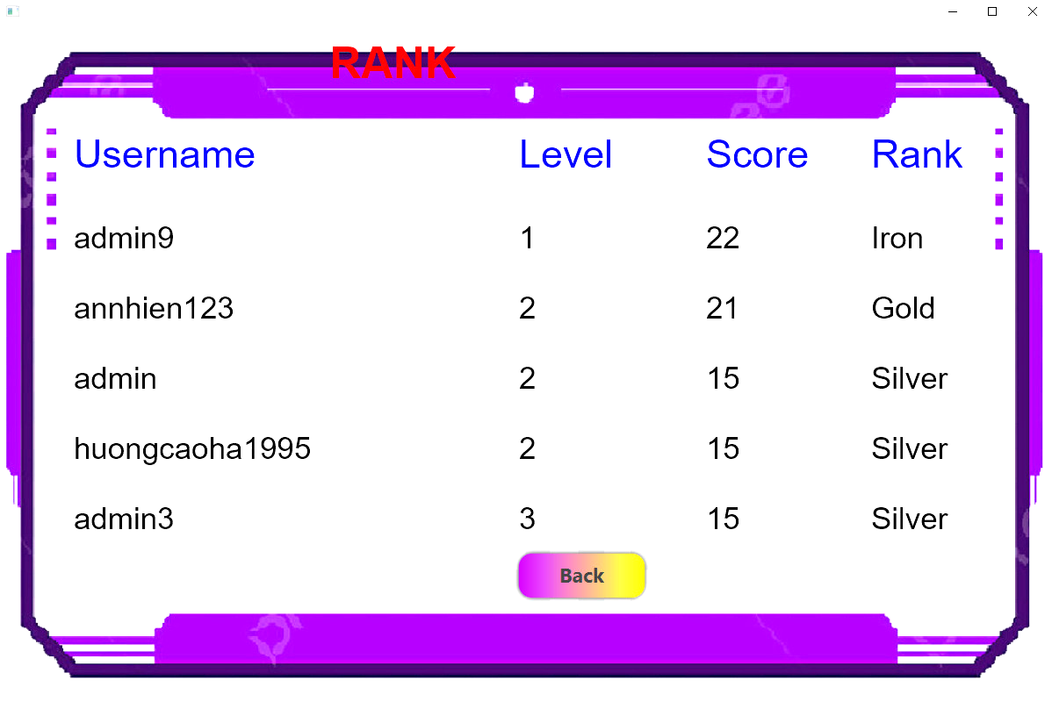

* In the leaderboard mode of the game, the score you achieve will be converted into gold. This means that as you climb up the leaderboard and achieve higher scores, you will earn more gold that can be used for purchasing costumes in the shop.
* If you wish to view your personal information, you can click on the avatar button within the game interface. Clicking on this button will open the information interface, which displays various details about your gameplay progress.

**Scene User Information**

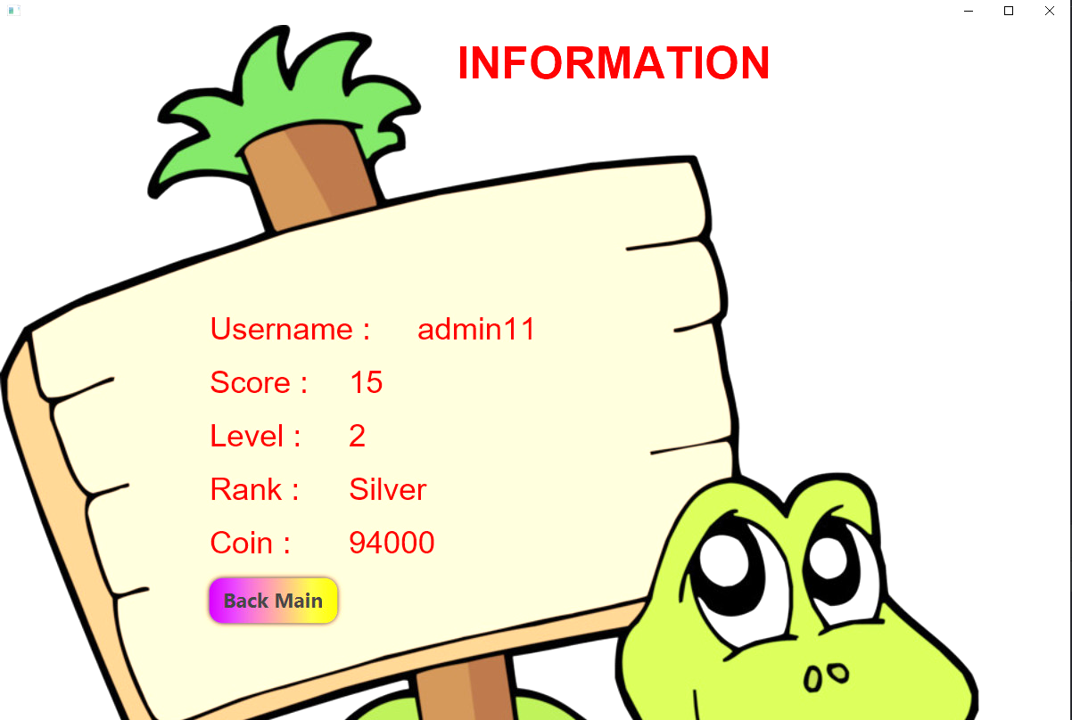

* The information interface consists of the following components:
* Information Label: At the top of the interface, there will be a label indicating that the displayed information pertains to your personal details.
* Username Label: Below the information label, there will be a label displaying your username or player name. This helps identify your account and personalize the information displayed.
* Level Label: Following the username label, there will be a label indicating your current level in the game. This represents your progress and shows which stage of the game you have reached.
* High Score Label: Below the level label, there will be a label showcasing your highest score achieved in the game. This highlights your best performance and serves as a benchmark for comparison.
* Back Button: Positioned at the bottom of the interface, there will be a back button. Clicking on this button allows you to return to the main game interface, where you can resume gameplay or access other features.
* The information interface provides a convenient way to view and track your personal details, such as your username, level, and high score. It helps you keep track of your progress and achievements within the game. By clicking on the avatar button and accessing this interface, you can easily review your information and then seamlessly return to the main game interface to continue playing.

**Scene MiniGame**

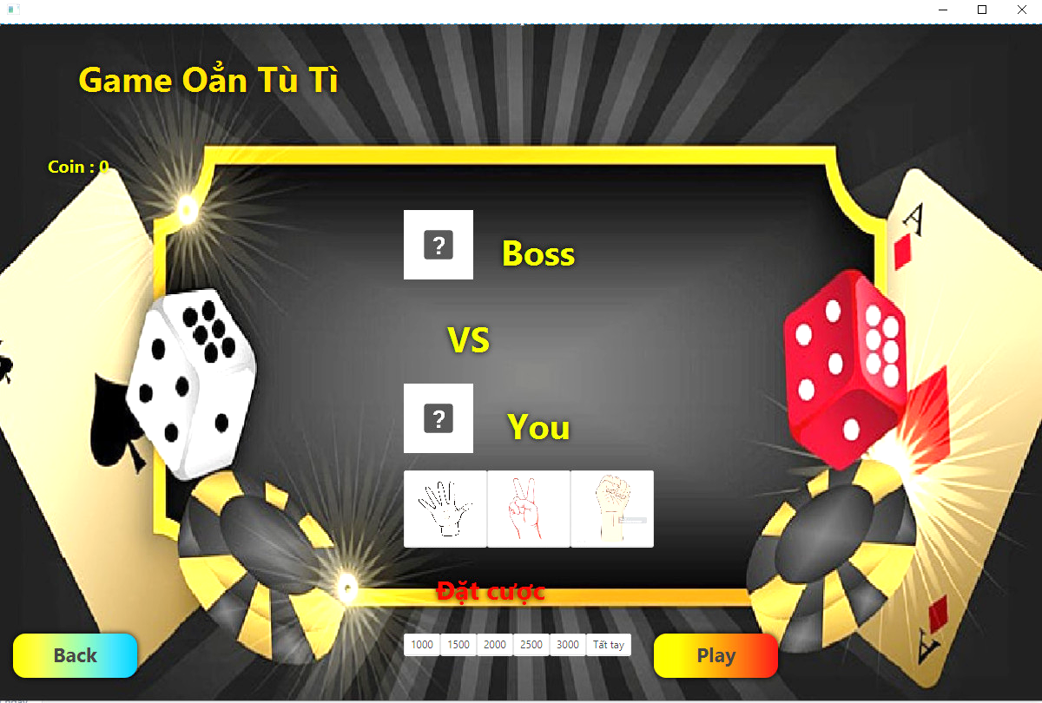

* MiniGame: In the MiniGame, there will be a betting interface where players can place bets with the boss. The interface will display three options at the top: leaf, scissors, and fist, representing the choices of "rock," "paper," and "scissors," respectively. The player will be able to select and play their chosen option by clicking on the corresponding button located on the left side of the interface. At the bottom, there will be a betting amount that the player can adjust to determine the number of points they want to bet against the boss.
* The objective of the MiniGame is to outsmart the boss by selecting the winning option. The boss's choice will be randomly generated, and the outcome will be determined based on the traditional rules of rock-paper-scissors: leaf beats scissors, scissors beats fist, and fist beats leaf. If the player wins the round, they will earn points based on the betting amount. However, if the player loses, they will lose the points they bet. In the case of a tie, no points will be gained or lost.
* The MiniGame adds an element of risk and strategy to the gameplay experience, allowing players to test their luck and skills against the boss. The betting amount provides a means for players to potentially increase their points or face the risk of losing them. It creates an additional layer of excitement and challenge within the game.
* All the screens are self-coded and only utilize JavaFX Scene Builder for interface customization.

**IV.Data Structure:**

* To represent the snake in the game, each element of the snake can be represented by an object. One way to achieve this is by creating a SnakePart class. The SnakePart class can have attributes that define the position of the element in the game space, such as coordinates (x, y). Each SnakePart object represents a segment of the snake's body.
* Similarly, the keys in the game can also be represented by an object. A keys class can be created to represent each key item in the game. The keys class can have attributes like coordinates (x, y) to determine the position of the keys item in the game space.
* To manage the game space, a GameSpace class can be created. The GameSpace class would store information about the size and state of the game space. It can have attributes such as width, height, and a 2D matrix that represents the state of each cell in the game space. This matrix can be used to track which cells are empty, occupied by the snake, or contain keys.
* In addition to the game space, the overall state of the game needs to be stored. This includes information such as the position and score of the snake. To handle this, a GameState class can be created. The GameState class would store attributes like the position of the snake (represented by a list of SnakePart objects), the score, and the current state of the game (e.g., playing, game over). The GameState class helps manage and update the overall state of the game as the player interacts with it.
* By utilizing these classes (SnakePart, keys, GameSpace, and GameState), you can effectively represent and manage the snake, keys, game space, and overall game state in the snake game. These classes provide a structured approach to organize and handle the various components of the game, making it easier to implement and maintain the game logic.

**V.Logic Play Game:**

* When a key is pressed in the game, it triggers an event that needs to be handled. The following actions are taken based on the specific key pressed:
* If the key is "up," the Y coordinate of the snake's position will be decreased by 1 square. This means that the snake will move upwards on the game space.
* If the key is "down," the Y coordinate of the snake's position will be increased by 1 square. This causes the snake to move downwards on the game space.
* If the key is "left," the X coordinate of the snake's position will be decreased by 1 square. This results in the snake moving towards the left side of the game space.
* If the key is "right," the X coordinate of the snake's position will be increased by 1 square. This causes the snake to move towards the right side of the game space.
* After updating the snake's position based on the key press, the "Draw" method is called. This method is responsible for redrawing the canvas or game screen with the updated position of the snake and other game elements.
* To check for collisions, the positions of the snake and the boss (or enemy) are compared. If the snake's position is the same as the boss's position, it indicates a collision between the two. In this case, the "gameover" scene or screen is triggered, indicating that the player has lost the game.
* Additionally, if the snake's position coincides with the position of a key (keys item), it signifies that the snake has successfully collected the keys. In such a scenario, the score is increased by 1 point. The "setkeys" function is then called to update the position of the keys item on the game space. Finally, the canvas is redrawn to reflect these changes.
* These actions provide the basic game mechanics of moving the snake, updating the game state, checking for collisions, and managing the score and key items within the game.

**VI.Data Storage:**

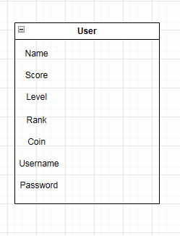

* Connecting to MongoDB:
  + To connect to MongoDB, you need the URI link to your MongoDB database. This link typically includes authentication credentials, hostname, port, and the name of the database.
  + You can use a MongoDB driver or library in your programming language of choice to establish a connection to the database using the provided URI.
* Accessing the Database:
  + Once connected, you can access the specified database within MongoDB using the connection object or method provided by the driver or library.
  + You can specify the name of the database in the URI link or select it programmatically after establishing the connection.
* Accessing a Collection:
  + Within the selected database, you can access a specific collection. Collections in MongoDB are similar to tables in relational databases.
  + You can use the connection object or method to reference the desired collection within the database.
* Querying the Collection:
  + MongoDB provides a flexible and powerful query language to interact with collections.
  + You can use methods or functions provided by the MongoDB driver or library to perform various types of queries, such as finding documents based on specific criteria, sorting, filtering, aggregation, and more.
  + The query syntax may vary slightly depending on the programming language and MongoDB driver or library you are using.
* User Registration:
  + Implement a user registration system where players can create their accounts.
  + Store user account information such as username, password (hashed for security), and any additional relevant details.
  + Use a secure method for password storage, such as hashing and salting, to protect user credentials.
* Score Update:
  + Track the score for each player during gameplay.
  + After each gameplay session, compare the new score with the player's existing score.
  + If the new score is higher than the existing score, update the player's score with the new value.
* Database Integration:
  + Utilize a database system, such as MongoDB or a relational database, to store player information and scores.
  + Design a schema or collection structure to store user accounts and scores.
  + Create appropriate database tables or collections to store the necessary information.
* User Authentication:
  + Implement a user authentication system to verify the identity of players during login.
  + Use secure authentication methods, such as token-based authentication or session management, to ensure secure access to user accounts.
* API or Backend Logic:
  + Create API endpoints or backend logic to handle user registration, login, and score updates.
  + Implement the necessary logic to validate user input, authenticate users during login, and update scores based on the game's outcome.
* Frontend Integration:
  + Develop a user interface that allows players to register, login, and view their scores.
  + Integrate the frontend with the backend API to communicate and exchange data between the user interface and the server.

**VII.Testing và debugging:**

* To assume the role of a player and interact with the game application, you can follow these steps:
* Launch the game application and navigate to the main menu or start screen.
* Choose the desired game mode, such as single-player or multiplayer.
* Start the game by selecting the preferred level of difficulty setting.
* Use the designated controls (keyboard, mouse, or touchscreen) to control the snake's movement.
* Move the snake in different directions (up, down, left, right) to navigate the game space.
* Collect the key items by maneuvering the snake to their positions.
* Observe the score increasing as you collect the key items.
* Be mindful of avoiding collisions with the boss or any obstacles in the game space.
* If a collision occurs, observe the "game over" scene or screen being triggered.
* Restart the game or return to the main menu to play again.
* Test different scenarios and edge cases, such as intentionally colliding with the boss or reaching the maximum score, to ensure the game handles these situations appropriately.
* Verify that any power-ups or additional gameplay elements function as intended.
* Pay attention to any audio or visual effects associated with gameplay events.
* Monitor for any errors, glitches, or unexpected behaviors during gameplay.
* Make note of encountered issues and try to identify their root causes.
* Analyze the codebase, debug problematic areas, and make necessary fixes to address the identified issues.
* Retest the game after applying fixes to ensure the errors have been resolved.
* Repeat the testing process for all game features, including movement, collision detection, scoring, and any other gameplay elements.
* Iterate through the process of identifying errors, applying fixes, and retesting until all identified issues have been resolved and the game functions smoothly.
* Provide feedback to the game developers if necessary, reporting any bugs or suggesting improvements to enhance the gameplay experience.
* By following these steps, you can thoroughly test the game's features, identify and fix errors, and ensure a smooth and enjoyable gaming experience.

**VIII.The expansion feature:**

* The team's plan to further develop the game with additional features is commendable. Here are some detailed explanations of the proposed features:

1.Competitive Scoring System:

* Implement a scoring mechanism that tracks and displays the scores of individual players. This can be done by assigning points to players based on their performance in the game, such as collecting keys items or surviving for longer durations.
* Display a leaderboard that ranks players based on their scores. This leaderboard can be visible during gameplay or at the end of each round, fostering a sense of competition among players.
* Ensure that the scoring system is fair and accurately reflects the players' achievements, providing an incentive for players to improve their performance.

2.Player-Versus-Player Mode:

* Introduce a multiplayer mode where players can compete against each other in real-time. This can be implemented through online multiplayer functionality or local multiplayer on the same device.

- Enable players to engage in head-to-head battles, where the objective is to devour opponents' characters. This adds an exciting and competitive element to the gameplay.

- Implement rules where a player's character can consume the character of an opponent who has a higher score. This allows players to gain their opponents' points and increase their own size, creating a dynamic and strategic gameplay experience.

3. Power-Ups and Special Abilities:

- Add power-ups or special abilities that players can acquire during gameplay. These power-ups can provide temporary advantages, such as increased speed, invincibility, or the ability to trap opponents.

- Strategically place power-ups throughout the game environment to encourage players to explore and take risks. This adds an extra layer of excitement and tactics to the gameplay, as players compete to acquire and utilize these power-ups effectively.

4. Different Game Modes:

- Introduce various game modes to cater to different player preferences and add variety to the gameplay experience. For example, include a time-based mode where players compete to achieve the highest score within a set time limit or a survival mode with increasing difficulty levels.

* Each game mode should offer a unique set of challenges and objectives, keeping players engaged and entertained. It is essential to balance the difficulty and provide appropriate rewards to ensure a satisfying gameplay experience.

5. Customization Options:

- Allow players to customize their snake characters with different colors, patterns, or skins. This provides players with a sense of ownership and allows them to personalize their gameplay experience.

- Provide options to customize the game environment, such as choosing different backgrounds or themes. This enhances player engagement and allows players to create a visually appealing and immersive gaming environment.

- By implementing these additional features, the team can enhance the gameplay experience, increase player engagement, and create a more competitive and dynamic game environment. It is important to thoroughly test and iterate on these features to ensure they function as intended and provide an enjoyable and balanced gameplay experience for all players.

**IX.Game Instructions:**

**Scene Guide Play**

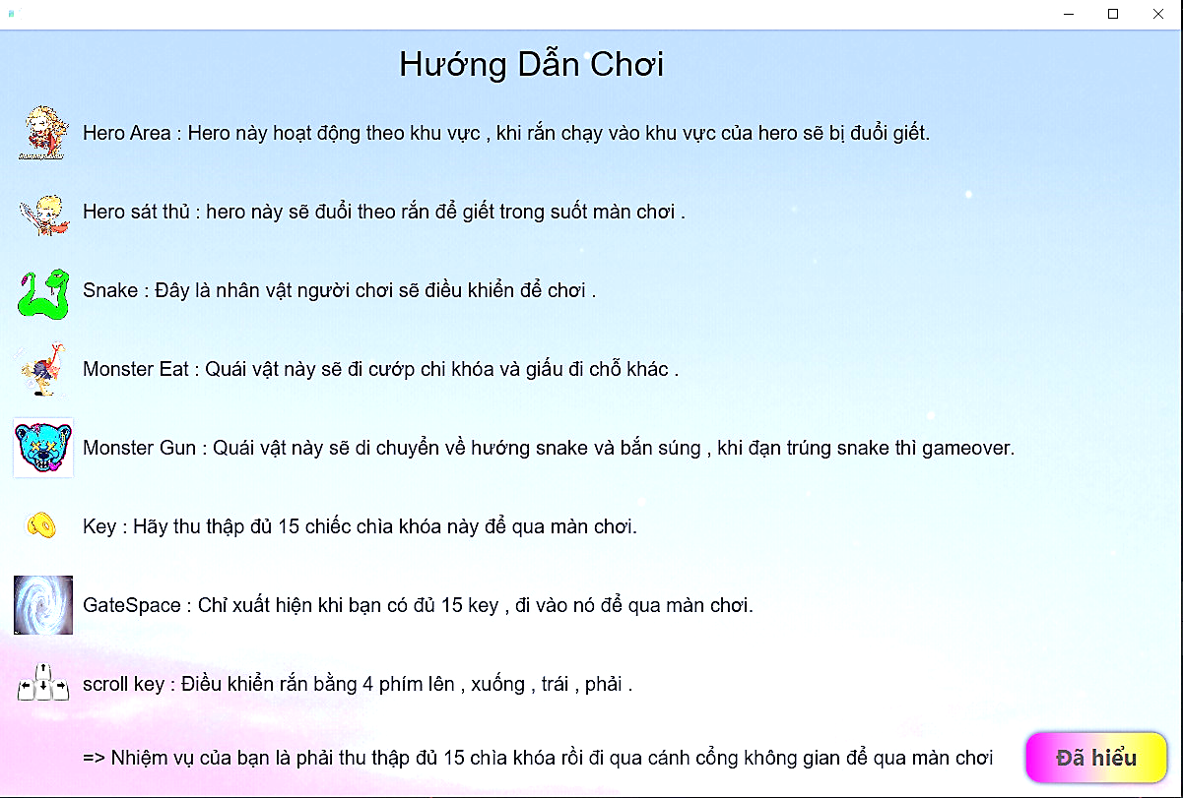

* In the game, you will start controlling a snake within a confined area. To maneuver the snake, you can use the arrow keys or the ↑, ↓, →, ← keys on the keyboard. The objective is to eat keys scattered throughout the playing area to survive and grow.
* As you navigate the game space, you will come across randomly appearing pieces of keys. Move the snake towards these keys and consume them to increase the snake's length. Each time you eat a key, the snake will grow longer by one unit.
* However, there is a challenge in the form of a red zone. When the snake enters the red zone, a boss character will start chasing the snake. It is crucial to avoid collisions with the boss by moving quickly and making strategic decisions. If the boss catches the snake, the game will end, and a game over screen will be displayed.
* To progress in the game, you need to level up by consuming enough keys. As you level up, the difficulty will increase, and more keys will appear for you to eat. Additionally, reaching a certain level will grant you access to a portal that allows you to move to the next level.
* The game features a leaderboard that tracks and displays the highest scores achieved by players. Your goal is to eat as many keys as possible to climb up the leaderboard and showcase your skills.
* Furthermore, players can view their battle history, which showcases their previous performances and results. This allows you to track your progress and evaluate your gameplay strategies.
* There are three different game modes available, each offering varying difficulty levels. You can choose the mode that suits your preferences and challenges yourself accordingly.
* Each player has a personal profile that displays their achievements and progress in the game. You can view your score, level, and the achievements you have earned.
* For customization options, players can choose different skins to change the appearance of their snake. You can access the interface section to select the skin that you prefer.
* The game also includes a shop where players can purchase various in-game items and upgrades using the in-game currency. Take a look at the available items in the shop and buy what you need to enhance your gameplay experience.
* In level 1, you will be rewarded with 500 coins, in level 2 with 1000 coins, and in level 3 with 1500 coins. These coins can be used to purchase characters in the shop.
* Enjoy the excitement of controlling the snake, eating keys, avoiding the boss, and progressing through levels to achieve high scores. Challenge yourself, have fun, and good luck in the game!

**X.Reference documents:**

* Youtube: <https://youtube.com/playlist?list=PL33lvabfss1yRgFCgFXjtYaGAuDJjjH-j&si=FYAkxC_rg3knF9x3>
* Chat GPT: Poe.com